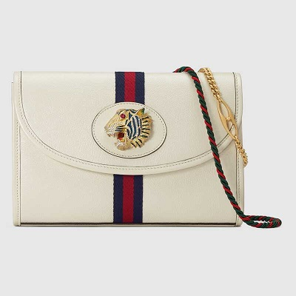

Rajah small shoulder bag

PRODUCT DETAILS

**An addition to the Rajah line for Spring Summer 2019, the small leather shoulder bag**

**features the collection's defining colored enamel and crystal tiger head, inspired by a**

**vintage piece from legendary fashion and jewelry designer Hattie Carnegie's 1940s**

**archives. Designed with two straps: one short chain strap and a longer shoulder strap in**

**the House's signature green and red Web colors.**

**Blue and red Web • Shiny gold-toned hardware • Rajah**